**BUSINESS INTELLIGENCE AND BUSINESS ANALYTICS**

**PROJECT IMPLEMENTATION DOCUMENT**

**SUBMITTED TO,**

**PROF. SEAN HEENEY**

**15-04-2020**

**SUBMITTED BY,**

**ARUNKUMAR SUDHAKARAN NAIR (19153317)**

**EVLIN BRIDGIT EMMANUEL (19153813)**

**MONISHA NAGESH (18193803)**

**ARATHY VIJAYAN (19148615)**

**Contents**

**1.** **Introduction:** 3

**2.** **B2C model:** 3

**2.1 Trust issues in B2C e-commerce model:** 4

**2.2 Lack of Clarity regarding the goods purchased:** 4

**3.** **SWOT Analysis of Wish.com:** 4

**3.1.** **Strengths:** 5

**3.2.** **Weakness:** 6

**3.3.** **Opportunities:** 6

**3.4.** **Threats:** 6

**4.** **Implementation in Dynamic CRM:** 7

**4.1.** **Creating Custom Entities:** 7

**4.2.** **Creating Custom Fields:** 7

**4.3.** **Create New Form:** 8

**4.4.** **Setting up relationships:** 8

**4.5.** **Publish the customizations:** 9

**4.6.** **Load the data:** 10

**4.7.** **Setting Business rules:** 10

**4.8.** **Seller Dashboard:** 11

**5. Implementation in Power BI:** 11

**1.1.** **Customer and Product Analysis** 12

**5.1.1** **Orders Placed by Each Customer:** 12

**5.1.2** **Customer Review Category:** 13

**5.1.3** **Product Name Categorisation:** 13

**5.1.4** **Order Line Status Summary:** 14

**5.1.5** **Customer Reviews:** 14

**5.1.6** **Highest Selling Product** 15

**5.2** **Seller Analysis:** 15

**5.2.1** **Total order by Seller ID:** 16

**5.2.2** **Seller Categorization:** 16

**5.2.3** **Customer Review Rating:** 17

**5.2.4** **Total Order Status:** 17

**5.2.5** **Authentic Seller Category:** 18

**5.2.6** **Average Rating for Each Seller:** 18

**5.2.7** **Sellers with maximum Customers** 19

**5.2.8** **Sellers with least Customer Rating:** 19

**References:** 20

# **Introduction:**

Nowadays customers are more aware of the products which they are purchasing, decisions are made based on the user affixed online ratings. The ratings are unbiased reflections of other customer's experiences. We are trying to analyse these customer ratings and to reduce the number of fraudulent sellers on the platform.

This method is implemented to improve the overall reputation and profitability of an organization, to uphold the customer trust and to detect the threats about the merchant fraud of Wish.com.

# **B2C model:**

Figure 1: B2C business model

B2C (business to consumer) model is be enabled in Wish.com to sell the products individually to the online customers. In this model, the website acts as a platform for sales to take place. Our organization, Wish.com is providing a space for the sellers to sell their products and the customers/buyers to purchase the products without going to a traditional shop for purchasing. Cheaper products are difficult to search in the traditional markets but are easily purchased in online marts. B2C has a subscription model where our organization will try to focus on the below listed three factors to gain the customer's attention.

* Continuous replenishment of products.
* Providing flat offers for customer preferred products.
* Including free shipment for the random picks of products.

## **2.1 Trust issues in B2C e-commerce model:**

If we analyse the virtual transactions of e-commerce, it can be observed that, when trading occurs in the virtual environment between the buyers and sellers, eventually trust will be developed based on long-term relationships. However, if a new buyer is introduced into the platform, it is difficult to establish the same trust. To gain customer trust, we are placing in a mechanism to detect fraudulent sellers based on the ratings/reviews given by the customer.

## **2.2 Lack of Clarity regarding the goods purchased:**

One of the main disadvantages of any B2C model is the lack of clarity for the buyers regarding the products they bought. The buyers will be purchasing goods based on the product description and the catalogue images which are listed on the website. This cannot be compared with the touch and feel experience which can be obtained while purchasing from a traditional store. This disadvantage of the model is one of the main reasons for the counterfeit and damaged products which are coming into the online platforms now. These disadvantages are being used by the fraudsters to bring counterfeit items into the market.

# **SWOT Analysis of Wish.com:**

SWOT stands for Strengths, Weaknesses, Opportunities, and Threats. The main objective of SWOT Analysis is to build on the organizational strength and minimize its weakness. Swot Analysis is a planning technique used by organizations to identify their strength, weakness, opportunities, and threats. This helps in the overall improvement of an organization in both an internal and external manner.

Figure 2: SWOT analysis

If we take a brief look at the SWOT analysis of our organization, we can understand the following:

* 1. **Strengths:**

**Huge product portfolio:**

The investment in the organization is large and therefore the organization drives more attention and also receives more return. For example, if a promotional offer is announced, more customers tend to be attracted, since more products can be introduced simultaneously.

**Fraud seller detection:**

Based on the customer ratings submitted in the feedback form, a fraud seller will be detected and removed by the manual investigators in the organization.

**Network reach:**

The Network reach of our organization is global. This is considered as one of the main strengths of our organization.

**Reduced Price:**

The price range is comparatively low in our organization compared to almost every other competitor.

**Huge discounts:**

The site offers ‘Hourly Discounts’ that can give discounts of 92% or more.

* 1. **Weakness:**

**High level of competitors:**

Our organization’s high-level competitors are Poshmark, eBay, Zulily, Wanelo, and ASOS, etc.

**Customer trust gets affected by the fraud seller:**

On delivery of the ordered product, if the quality doesn’t meet its level of esteem then customers trust towards the respective products seller will be lost.

**Counterfeit products in the platform:**

Even though the company headquarters is in San Francisco, the products are coming from China. This increases the chance of counterfeit products coming into the platform.

## **Opportunities:**

**Geographic extension & increase in internet penetration:**

Even though our organization reaches most of the countries, it still has a scope of improvement. Expanding the market can help to improve the organization rank from #6 to #1.

**Identifying the best quality sellers:**

By removing the fraudulent sellers, there arises an opportunity for us to identify the genuine sellers and keep them on the platform and provide additional benefits to them if necessary.

## **Threats:**

**Competitors catching up:**

There are more chances to lose our unique pattern of sales because any one of the competitors can copy that same pattern.

**Inability to meet the standards:**

Defects in the products or failure in the quality will not allow meeting the customer's expectation levels.

**Summary of SWOT Analysis:**

This analysis helps the company to know its merits and demerits and it determines where the company currently stands in the market. Each parameter of this analysis namely, strength which shows the confidence of the company, weakness which reveals the factors within the company on which it should work on, an opportunity that informs the chances that are available to increase the customer of the firm and lastly counteract the threats.

# **Implementation in Dynamic CRM:**

We will be using dynamic 365 for executing our approach to communicate with various departments in our organizations. Microsoft Dynamic 365 is based on the latest app source platform of Microsoft, where we can find different applications that fit our business needs. It provides a 365-degree view of our organization by combining ERP, CRM, Office and additional apps into a single cloud-based common data model.

The methodology we have used in dynamic 365 is explained below.

## **Creating Custom Entities:**

The entities are used to model and manage business data. Here, we are creating a custom entity named as seller and provided the areas where this entity should appear.

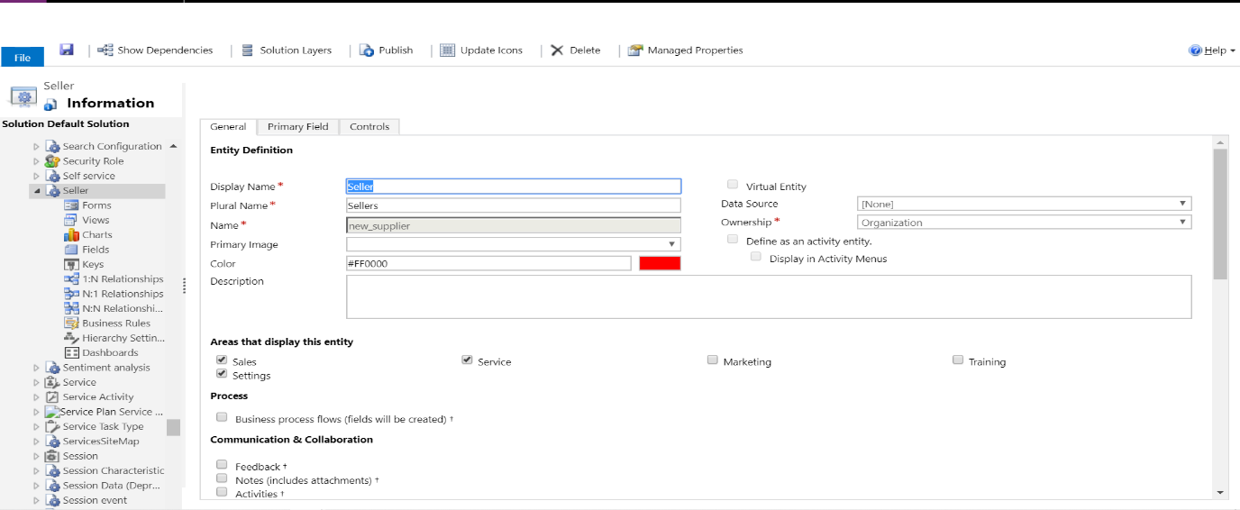

Figure 3: Creating custom entities

## **Creating Custom Fields:**

The next step is to create custom fields as per our needs. For this, we click on the create new field option and set the name of the field as Name. Here the Name attribute depicts the name of the seller. Likewise, we created fields like Customer, Customer Rating and Seller Status. The Customer field was created using the lookup data type. The intention was to look up for the available list of customers. The Seller Status section was added with two options as either fraud or not a fraud.

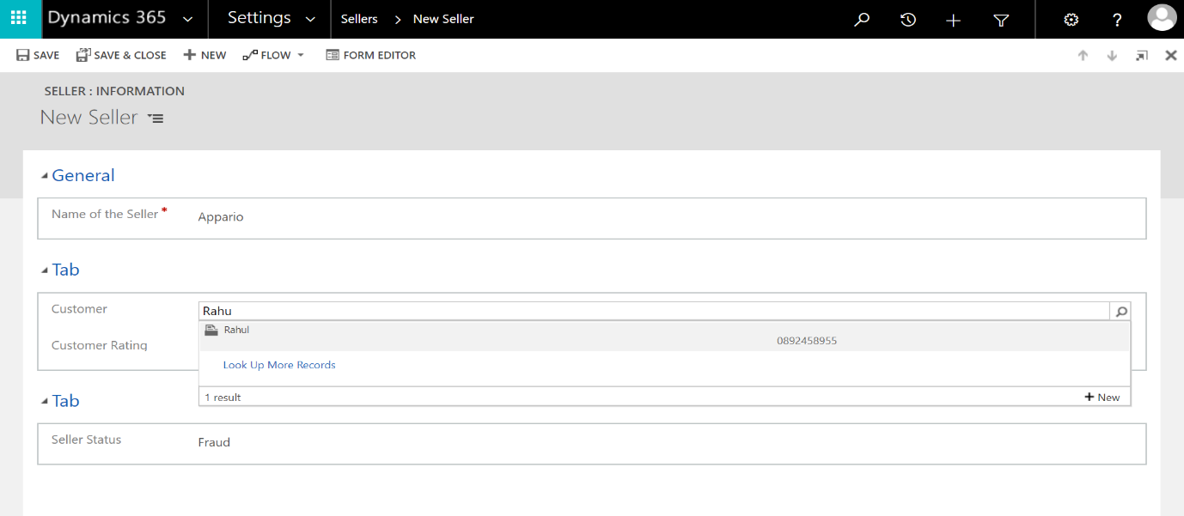

Figure 4: Creating Custom Fields

## **Create New Form:**

After we have created the fields, we will then create a new form and add the required fields to the form. The Name section was added initially to the form. Then the Customer section was added along with the Customer Rating as a subsection.

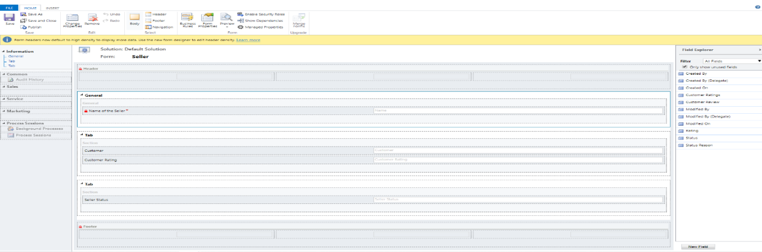

Figure 5: Creating new form

## **Setting up relationships:**

After setting up the fields and forms, we have to specify the type of relationship within the entity. Since the seller is having a relationship with multiple entities, we have set up a one to many relationships.

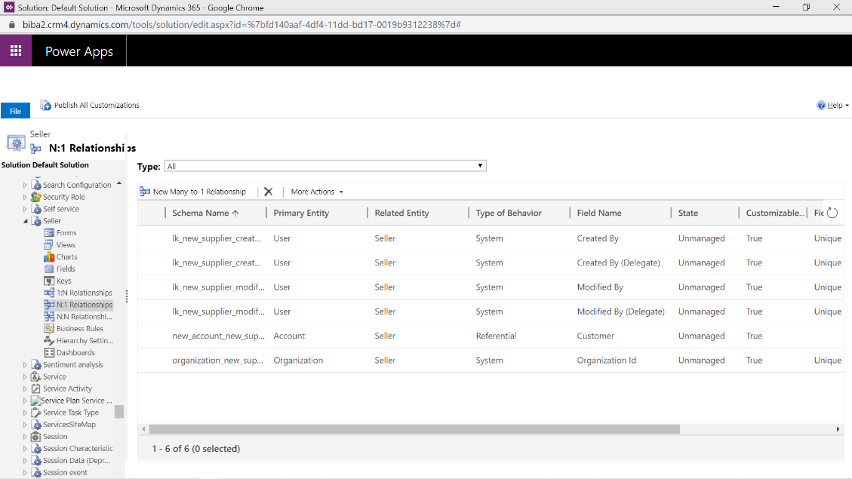

Figure 6: Setting up a relationship

## **Publish the customizations:**

The final step in creating an entity is to publish it. For this, we have to select the option ‘publish all customizations. Once we publish our customizations, the entity is visible in our specified areas.

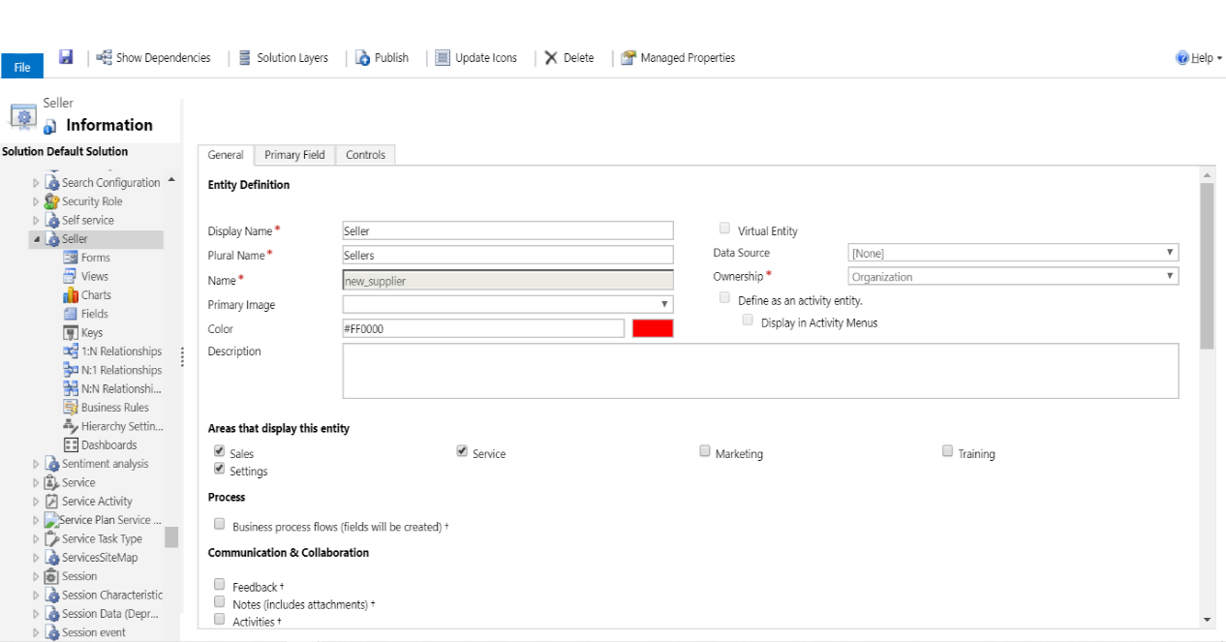

Figure 7: Publish the customizations

## **Load the data:**

We have created a dummy dataset with 10 customers given ratings for 30 sellers. Initially, we have created a custom dashboard with the names of the fields of the data which we are importing to dynamic 365. Then once the data is imported, data is mapped to the respective fields.

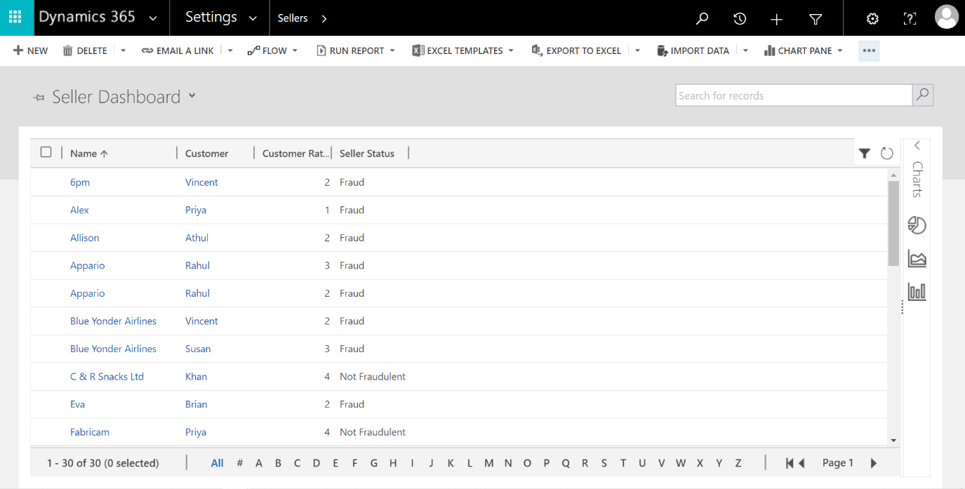

Figure 8: Load the data

## **Setting Business rules:**

The data sets with customer ratings are loaded to the system and then our main aim is to differentiate sellers based on the review. For this, we have created a business rule based on a threshold value. The rule states that if the customer value is less than or equal to 3, the seller status is set to Fraud. After business rules are set, publish all customizations and we are done.

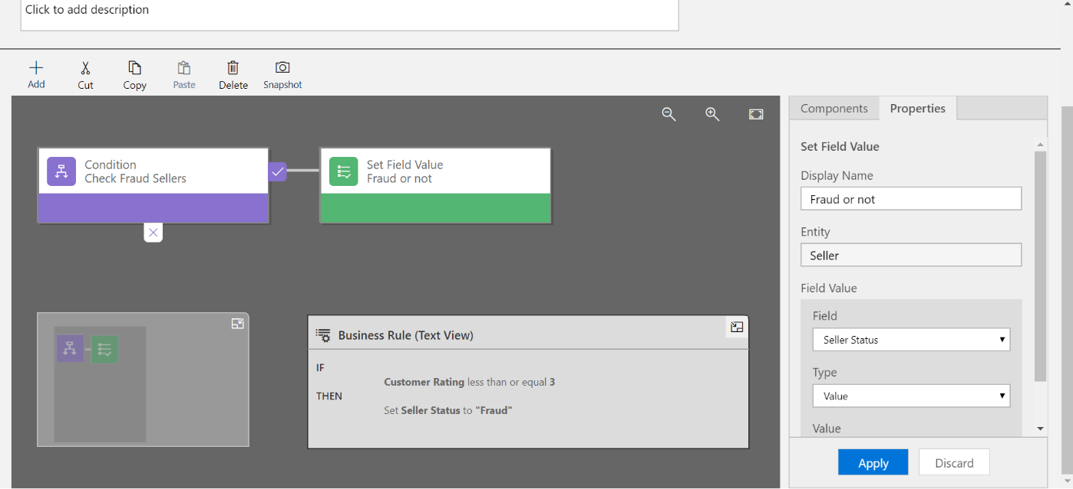

Figure 9: Setting the Business rules

## **Seller Dashboard:**

Once the above customizations are published, the dashboard will look like the one below. Here, we have also visualized the seller ratings for a better understanding.

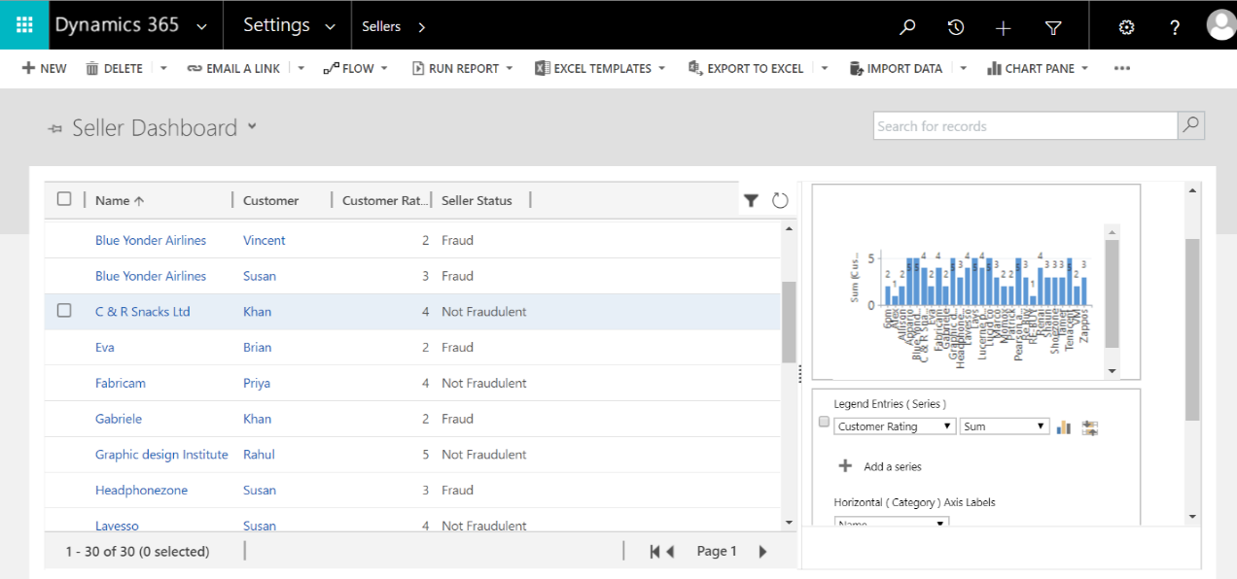

Figure 10: Seller Dashboard

# **5. Implementation in Power BI:**

Power BI is a tool used for analyzing and performing an interactive visualization with a very simple interface. For our model, we have created a mock dataset prioritizing the following fields:

* Customer details
* Seller details and
* Orders placed by the Customer to check whether the seller is fraud or not.

With the help of the data, we are performing six charts in Power BI to understand the Seller relationship with the company.

## **Customer and Product Analysis**

The below dashboard explains the overall customer and product dataflow in our organization.

Figure 11: Customer and Product analysis

* We can now analyse each of these dashboards in a detailed manner:

### **Orders Placed by Each Customer:**

Figure 12: Orders Placed by Each Customer.

* Figure 12 represents the number of orders placed by each customer. For example, customer ID 10212 has placed 16 orders in Wish.com.

### **Customer Review Category:**

Figure 13: CUSTOMER REVIEW CATEGORY

* Based on the customer rating a count of 1708 sellers are considered to be “PASS” and 520 are given “NEGATIVE” rating. For this, we have set a threshold rating value as 3. Any rating less than 3, becomes a negative rating and which is greater than 3 becomes a positive rating.

### **Product Name Categorisation:**

Figure 14: PRODUCT NAME CATEGORIZATION.

* Figure 14 depicts a variety of products that are available in our organization, Wish.com.

### **Order Line Status Summary:**

Figure 15: ORDER LINE STATUS.

Figure 15 displays that 6.73% of buyers who have placed the orders are not satisfied with the product supplied by their seller which implies a chance for 6.73% of the sellers to be moved into the fraudulent queue. The rest 93.27% of the buyers are satisfied with the items received from the sellers.

### **Customer Reviews:**

Figure 16: CUSTOMER REVIEWS.

The customer reviews given by the customers are stored in the database, the words which were used mostly by the customers are visualized in figure 16.

### **Highest Selling Product**

Figure 17: Highest Selling Products.

Figure 17 shows the product code and its respective number of items available in the organization currently.

**Overall Summary:**

Customer product analysis displays the number of products available in the organization, whether the order placed is valid and also about the customer reviews after the product is delivered.

## **Seller Analysis:**

Figure 18: Seller Analysis.

The above figure shows the overall seller data analysis of our model. We can now analyze each dashboard one by one in detail:

### **Total order by Seller ID:**

Figure 19: Seller Analysis.

Figure 19 shows the total number of orders placed on the respective Seller ID. For instance, as shown in figure 4 there are five orders placed on 370 seller ID.

### **Seller Categorization:**

Figure 20: Seller Categorisation

The sellers can be divided into the following categories:

* Trustworthy Seller
* Moderate Seller and
* Fraud Seller

Figure 5 depicts that 76.66% of sellers are considered to be trustworthy, 12.70% of sellers are moderate and based on the ratings less than 3 there are 10.64% of sellers are identified to be as fraudsters.

### **Customer Review Rating:**

Figure 21: Customer Review Rating

Figure 21 shows the customer ratings for every single value. Say for example 54.3% of customers have given ‘5’rating for the products.

### **Total Order Status:**

Figure 22 Total Order Status.

Figure 22 depicts that the total number of orders is divided based on the order status as ‘pass’/ ‘fail’.

### **Authentic Seller Category:**

Figure 23: Authentic Seller Category

The above chart displays the three threshold values: Pass, TP+ negative/positive and TP+negative. Pass percentage is 76.66 which represents the trustworthy sellers. Grey color 10.64% whose threshold value is TP+negative represents the fraud sellers.

And 12.7% of moderate customers are displayed in figure 8.

### **Average Rating for Each Seller:**

Figure 24: AVG. Rating For each Seller

Figure 24 represents the average rating given by the customer for each seller.

### **Sellers with maximum Customers**

Fig 25:Sellers with max customers

Fig 25 details about the count of the customers who purchases items to the respective seller.

This shows the seller id with the maximum count of customers indicates that they are a trustworthy seller enterprise.

### **Sellers with least Customer Rating:**

Fig 26: Sellers with Least Rating

Seller id’s which is lesser than 3 in customer rating is shown in fig 26.

**Overall Summary of Seller Analysis in dashboards:**

* Based on the Customer ratings categories of sellers are visualized as :
* Trustworthy Seller - 76.66%
* Moderate Sellers - 12.70%
* Fraud Sellers – 10.64% are available in the market.

# **References:**

[1] "Trust Study of E-Commerce in China Based on B2C Model - IEEE Conference Publication", *Ieeexplore.ieee.org*, 2020. [Online]. Available: https://ieeexplore.ieee.org/stamp/stamp.jsp?tp=&arnumber=5208817. [Accessed: 11- Apr- 2020]

[2] *Arxiv.org*, 2020. [Online]. Available: https://arxiv.org/ftp/arxiv/papers/1805/1805.00464.pdf. [Accessed: 11- Apr- 2020].

[3] H. Bhasin, "SWOT analysis | SWOT matrix | SWOT Template | SWOT Examples", *Marketing91*, 2020. [Online]. Available: https://www.marketing91.com/swot-analysis/. [Accessed: 11- Apr- 2020].

